**Assignment 1**

**Information Security**

**Section: B**

**Name: Muhammad Umar Ali**

**Roll no: 22-10507**

**Steps and commands to conduct the attack**

ipconfig

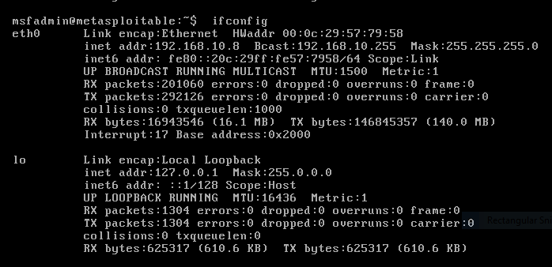

**Kali Linux**

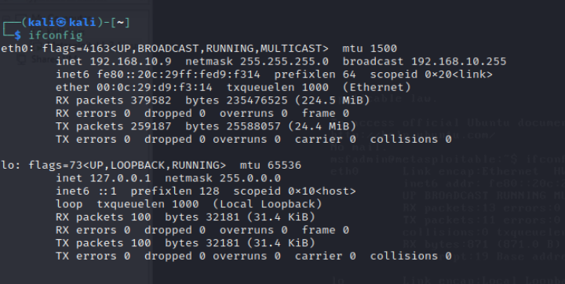

**Metasploit**



**Kali linux terminal**

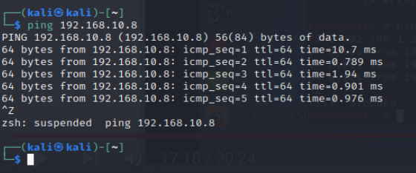

**Browser Connection check**

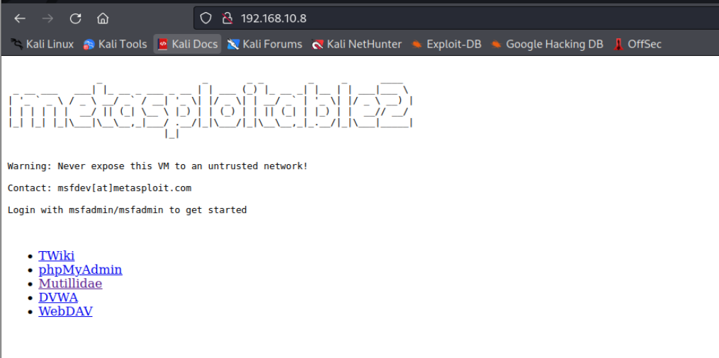

**Go on Multillidae**

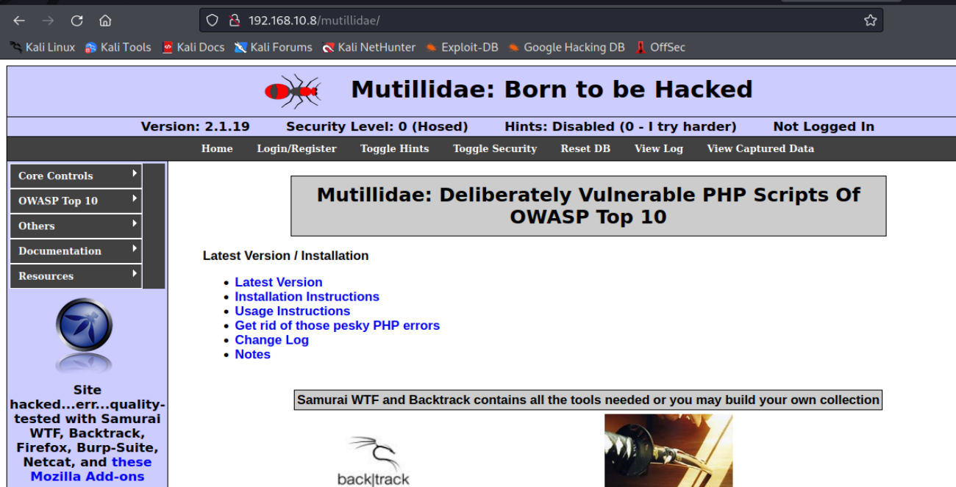

**Check for injections in OWASP**

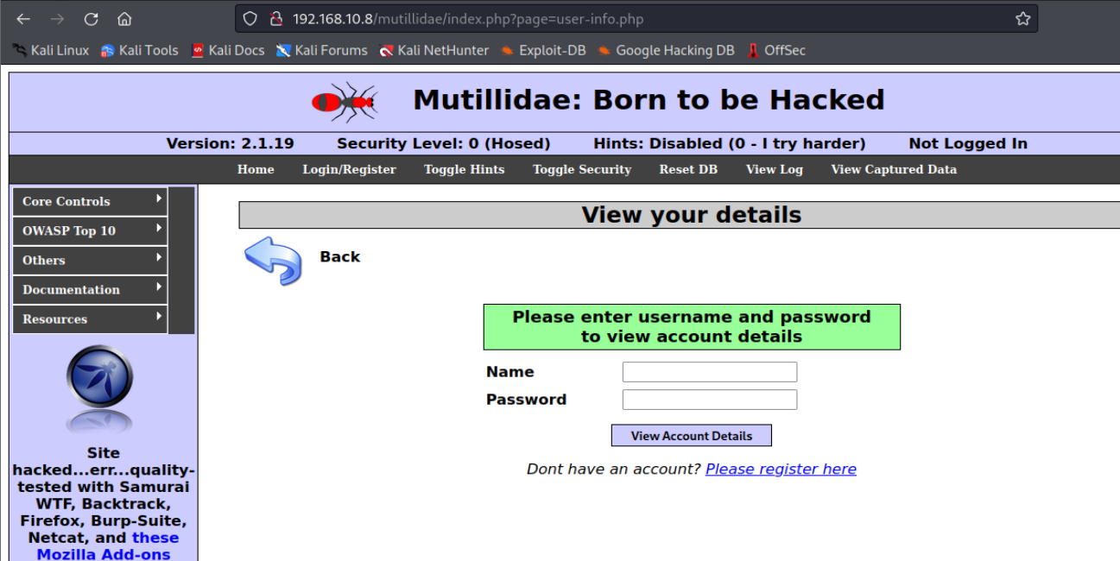

**Open Burp Suite Tool**

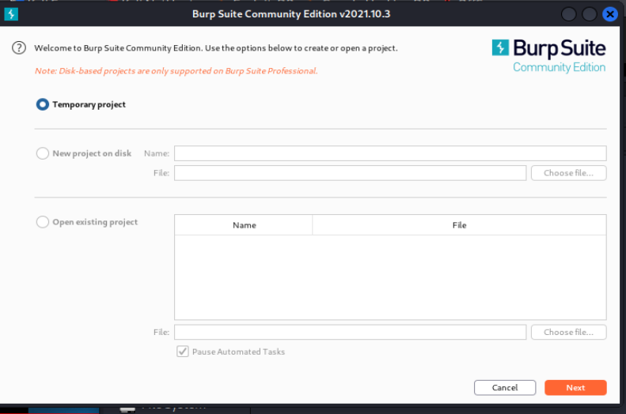

**Check for Proxy IP Address**

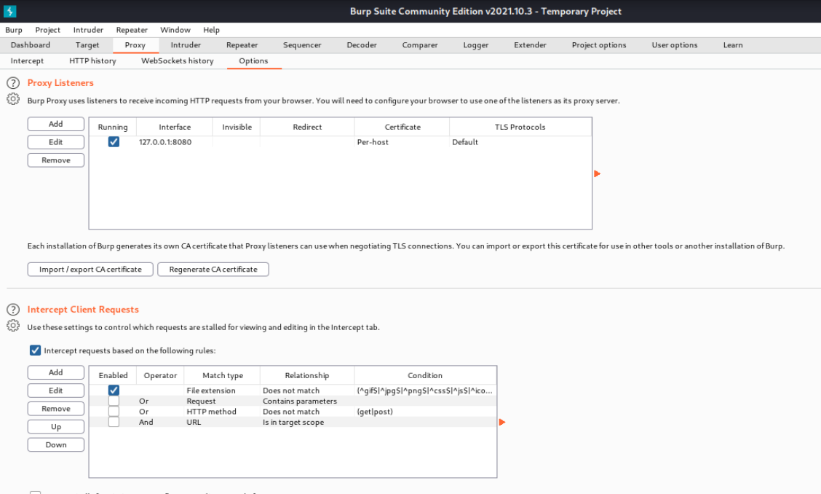

**Enter Random name and Password**

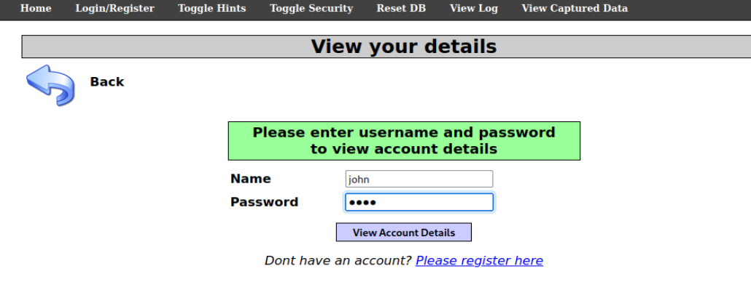

**Intercept the BurpSuit Terminal & save the file**

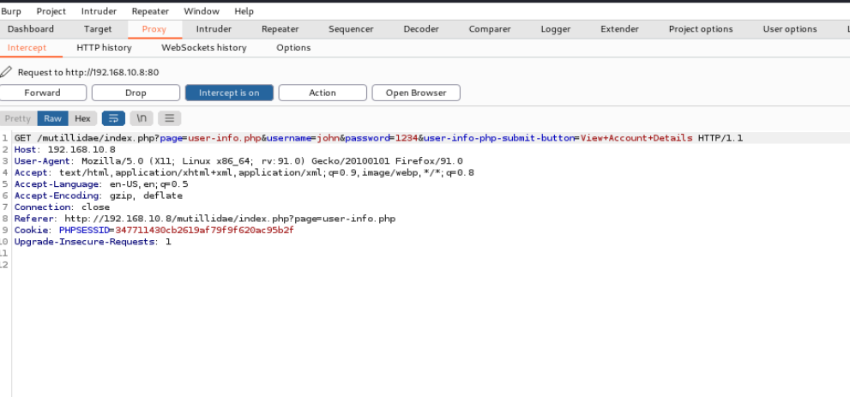

**Run sqlmap command**

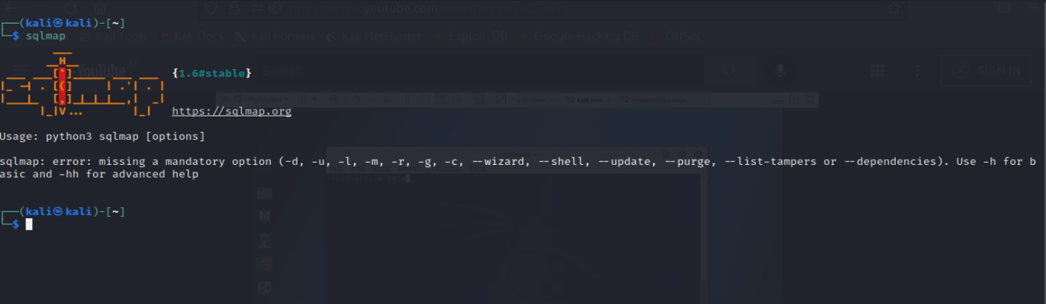

**Run command to read that file:**

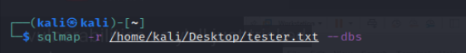

**User have No data in their database**

